**Millionaire**

**Millionaire** is an early prototype model of “Who Wants to be a Millionaire” game show. You are asked to create this game prototype using **C Programming Language**. Below are the requirements for this application.

1. **Home Screen**

Millionaire consists of three main menus as shown in **Figure 1**, they are:

1. **Let’s Play!!**
2. **Hall of Fame**
3. **Exit and Save Hall of Fame**

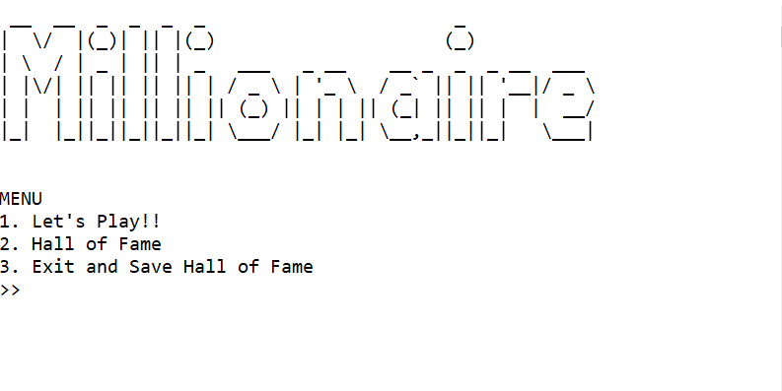

Figure 1. Home Screen of Millionaire

When **Millionaire** is **launching,** itwill **loads** **two** **files**, they are:

1. **“questions.txt”** file to load **questions** used in this game. The game will **abort** it’s launch if the file does not exists as shown in **Figure 2**.



Figure 2. Millionaire Abort It’s Launch When It is Fails to Load “questions.txt” File

1. **“scores.txt”** file to load **hall of fame** data. The game will **continue** it’s launch even if the file does not exists. However it will shows a warning message as shown in **Figure 3**.



Figure 3. Millionaire Show Warning Message When It is Fails to Load “scores.txt” File

1. **Menu 1 – Let’s Play!!**

* The game will display the **player** **progress** towards **$1000000** prize as shown in **Figure 4**. There are **15** **milestones** that **separated** **into** **3 prize range zones**: **$500 - $5000, $7500 - $50000, and $75000 - $1000000**. Each prize range has **a** **safe** **zone**, that later on will be discused to **calculate** the **player’s prize**.
* Each game session will have **different order of** **questios** **appearance**.

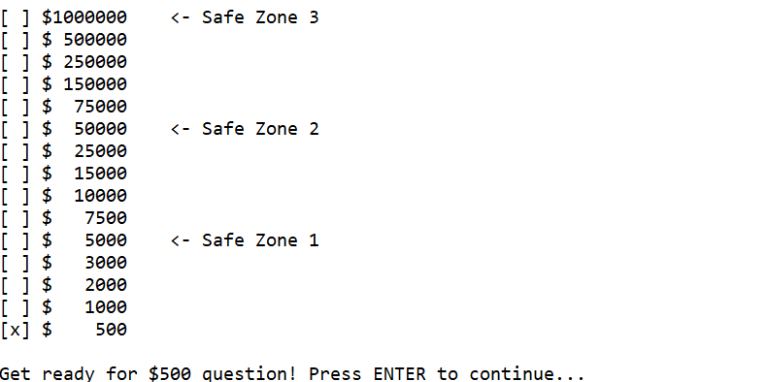

Figure 4. Player Progress Toward $1000000

* The game then will display **question** **for** **that** **level** as shown in **Figure 5**. Each question has **four** **possible** **answers**. Player can input **each** **respective** **characters** to answer (**‘A’, ‘B’, ‘C’, and ‘D’**). The Player can also:

1. **Input ‘E’** to use **50:50** as shown in **Figure 6**. This feature will **remove** **two** **out** **of** **four** possible answer. This feature can only be used **once** **per** **game** **session**.
2. **Input ‘F’ to surrender** as shown in **Figure 7**. This will **ends** the **game** **session** and the player will **receive** **half** **of** **the** **prize** **achieved** before.

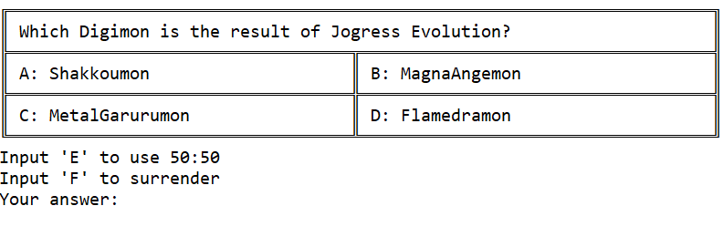

Figure 5. Question Displayed for Current Level

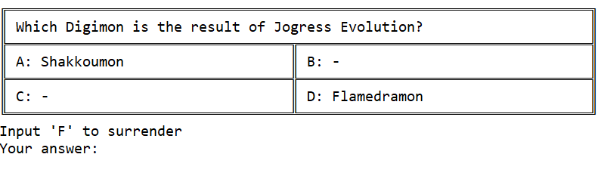

Figure 6. Question Displayed for Current Level After Using 50:50



Figure 7. Game Over When Player Choose to Surrender

* If the player **answer** **correctly**, the game will **move** **on** to the **next** **milestone** as shown in **Figure 8**.

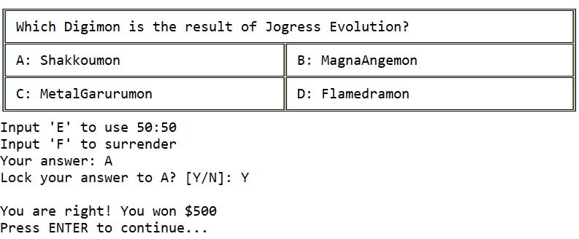

Figure 8. Player Correctly Answer the Question

* If the player **answer** **incorrectly**, the game will **be over** as shown in **Figure 9**.



Figure 9. Player Incorrectly Answer the Question

* If the player reach **the** **last** **milestone**, show a special message as shown in **Figure 10**.



Figure 10. Player Won $1000000

* Everytime the player **surrender**, **answer** **incorrectly**, or **reach** **the** **last** **milestone**, they will be asked for **nickname**. This nickname will be **saved** in **Hall of Fame**.

1. **Menu 2 – Hall of Fame**

* This menu will show **list** **of** **all** **user** that play **Millionaire** game as shown in **Figure 11**. The score will be **sorted** in **descending** order **based** **on** **the** **prize** they won. If there are **multiples** **user** **won** **the** **same** **amount** **of** **prize**, the scores will be **sorted** **based** on **nickname** in **ascending** order.
* This **score** **data** will be **saved** in **“scores.txt” file.**

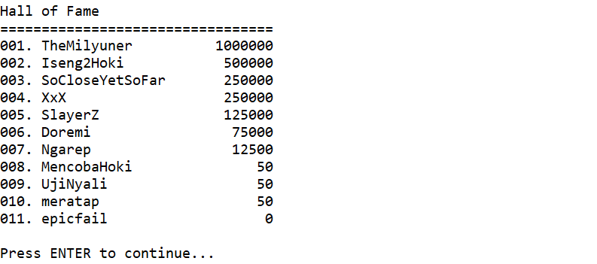

Figure 11. Hall of Fame

1. **Menu 3 – Exit and Save Hall of Fame**

* This menu will **save** the **recently** **new** **scores** added to **Hall of Fame** into **“scores.txt”.**
* After that the game will **exit** as shown in **Figure 12**.

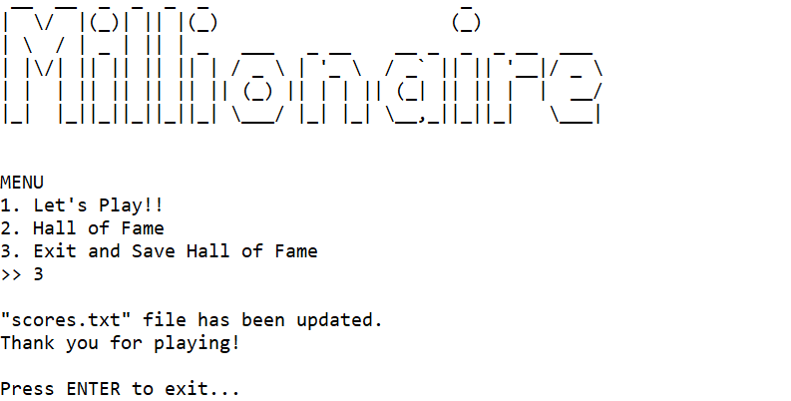

Figure 12. Exit and Save Hall of Fame

**Please run the executable file for further details of the game.**

“Talk is cheap. Show me the code.” ― Linus Torvalds

**-- Good Luck Have Fun --**